**Lab Practical #01:**

Study of basic networking commands and IP configuration.

**Practical Assignment #01:**

1. Perform and explain various networking commands listed below:
   1. ipconfig
   2. ping
   3. getmac
   4. systeminfo
   5. traceroute / tracert
   6. netstat
   7. nslookup
   8. hostname
   9. pathping
   10. arp

## ipconfig

### Description: The ipconfig command is used to display information about your network configuration and refresh DHCP and DNS Settings.

**--------- Details About Command ------**

|  |  |  |
| --- | --- | --- |
| No. | Option | Description |
| 1 | ipconfig /renew | That command **orders your DHCP client to renegotiate an IP address (IPv4) lease with the DHCP server on your router**. |
| 2 | ipconfig /renew6 | That command **orders your DHCP client to renegotiate an IP address (IPv6) lease with the DHCP server on your router**. |
| 3 | ipconfig /allcompartments | Show information about all compartments. |
| 4 | ipconfig /displaydns | Display the contents of the DNS Resolver Cache. |
| 5 | ipconfig /flushdns | Purges the DNS Resolver cache. |

### Implementation:

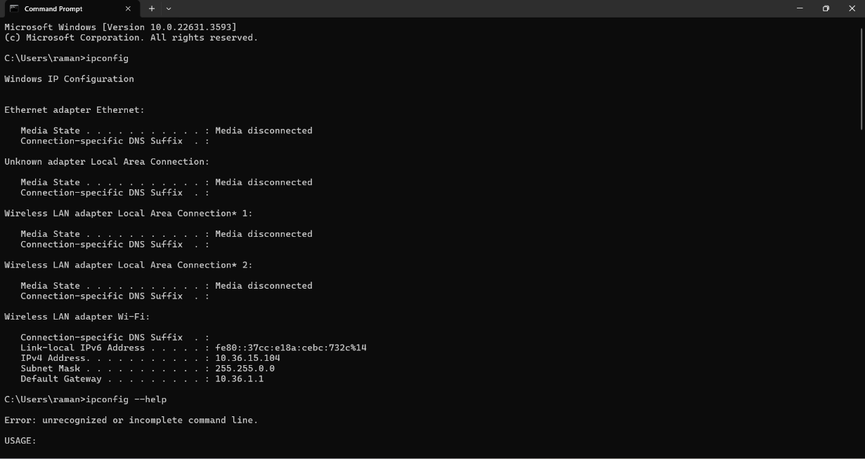

**ipconfig /renew**

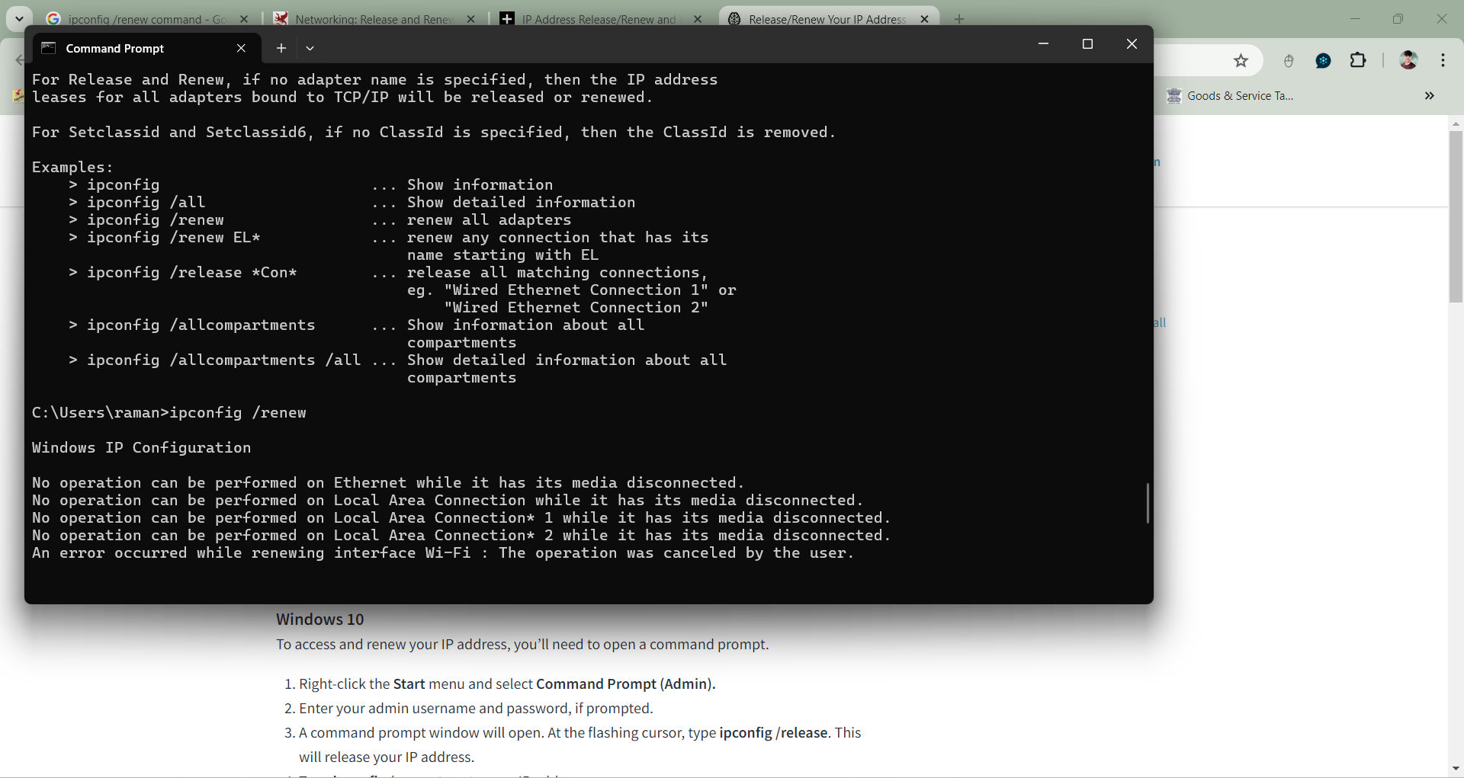

**ipconfig /renew6**

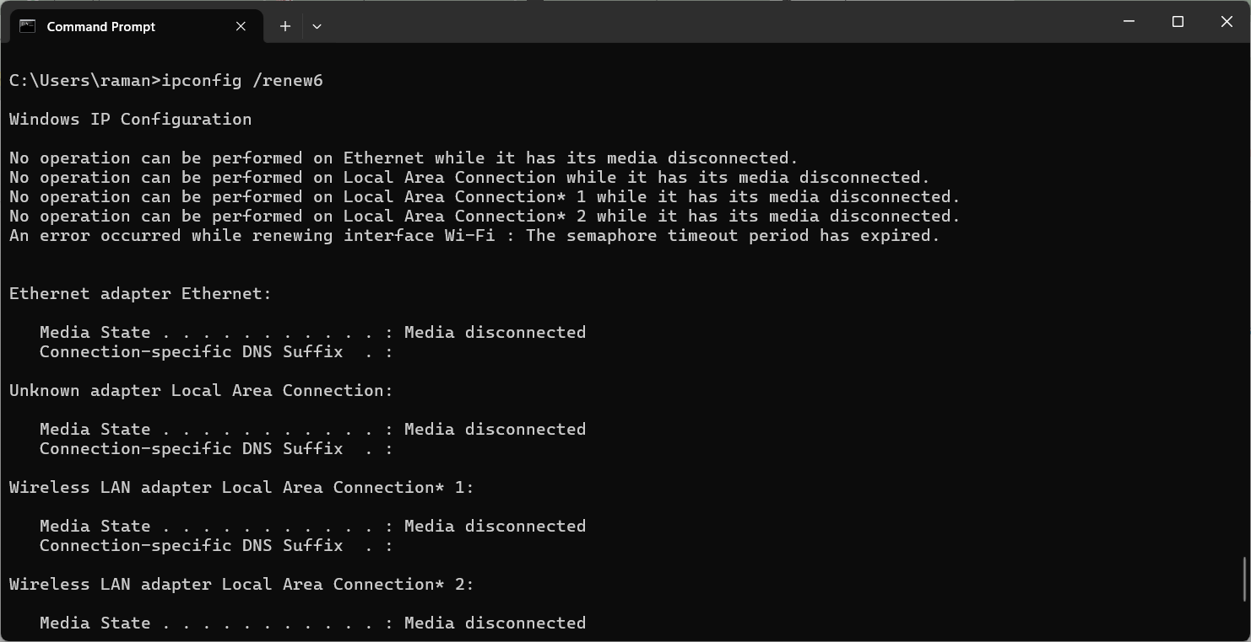

**ipconfig /allcompartments**

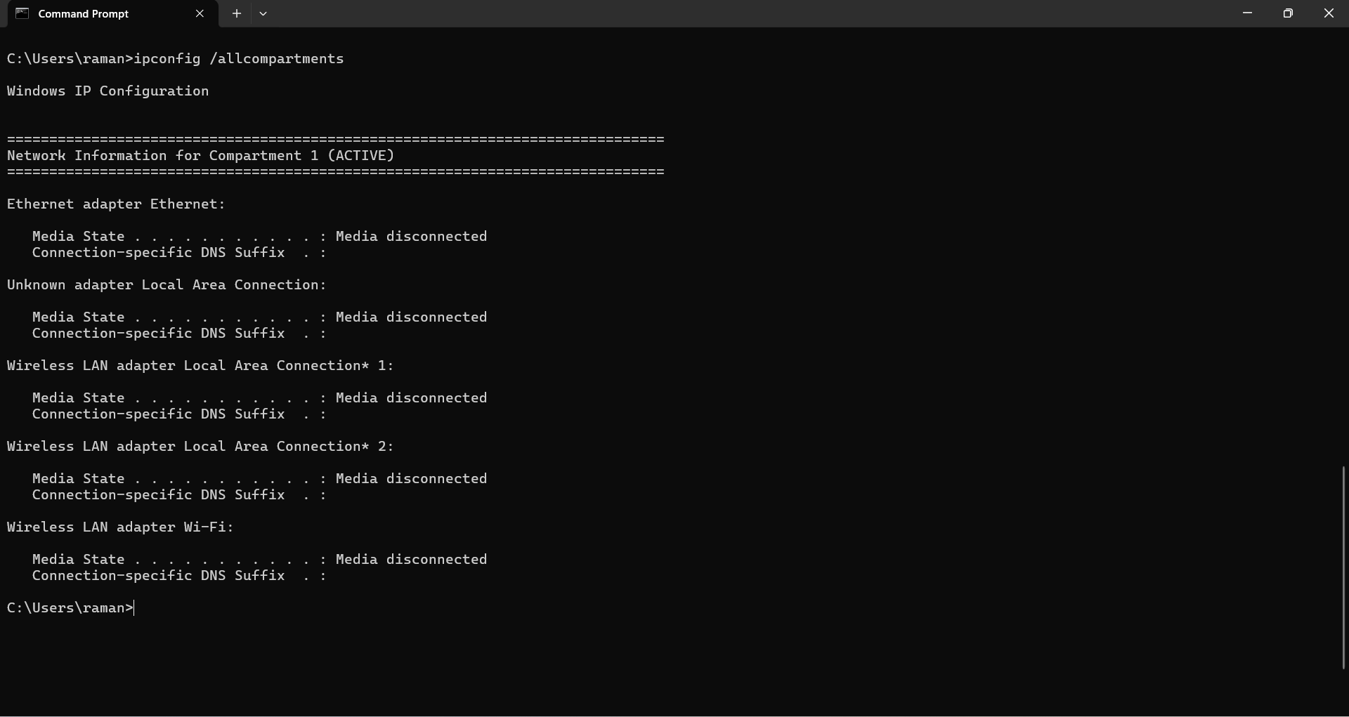

**ipconfig /displaydns**

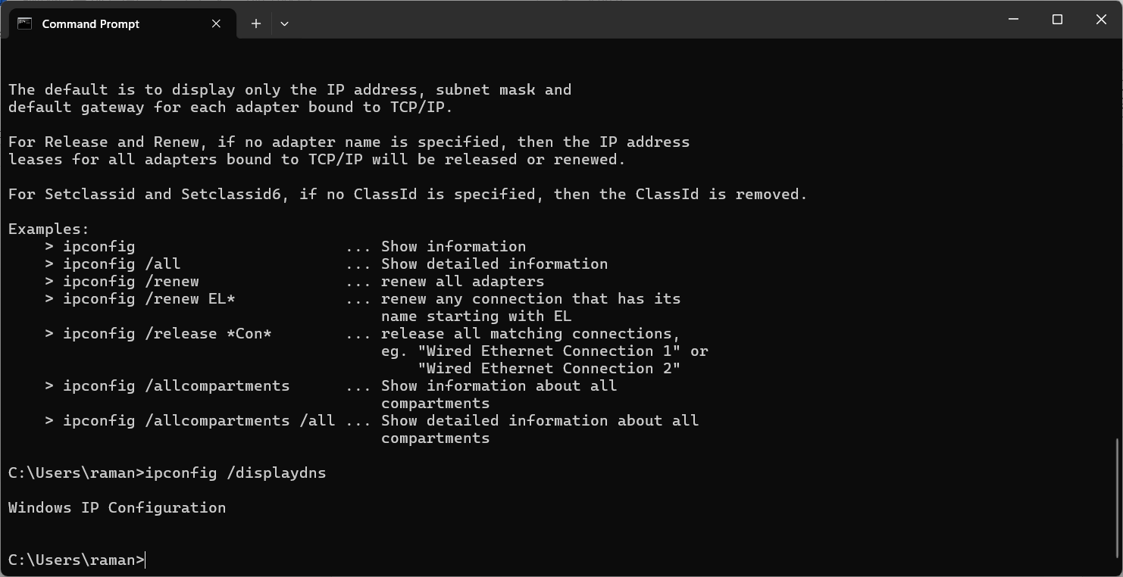

**ipconfig /flushdns**

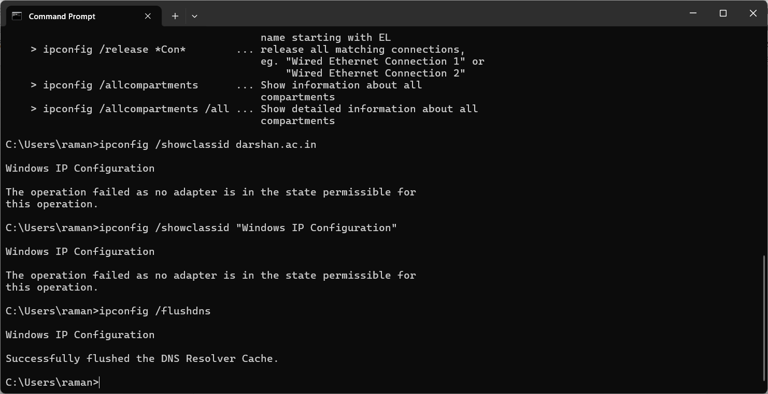

## ping

### Description: The ping command sends a request over the network to a specific device.

**--------- Details About Command ------**

|  |  |  |
| --- | --- | --- |
| No. | Option | Description |
| 1 | ping -t [DOMAIN_NAME/IP] | That is sends continues request (while key-board interrupt not occur) over the network to a specific device. |
| 2 | ping -n [number] [DOMAIN_NAME/IP] | Number of echo requests to send. |
| 3 | ping -4 [DOMAIN_NAME/IP] | Force using IPv4 |
| 4 | ping -6 [DOMAIN_NAME/IP] | Force using IPv6 |
| 5 | ping -i [number] [DOMAIN_NAME/IP] | Time To Live |

### Implementation:

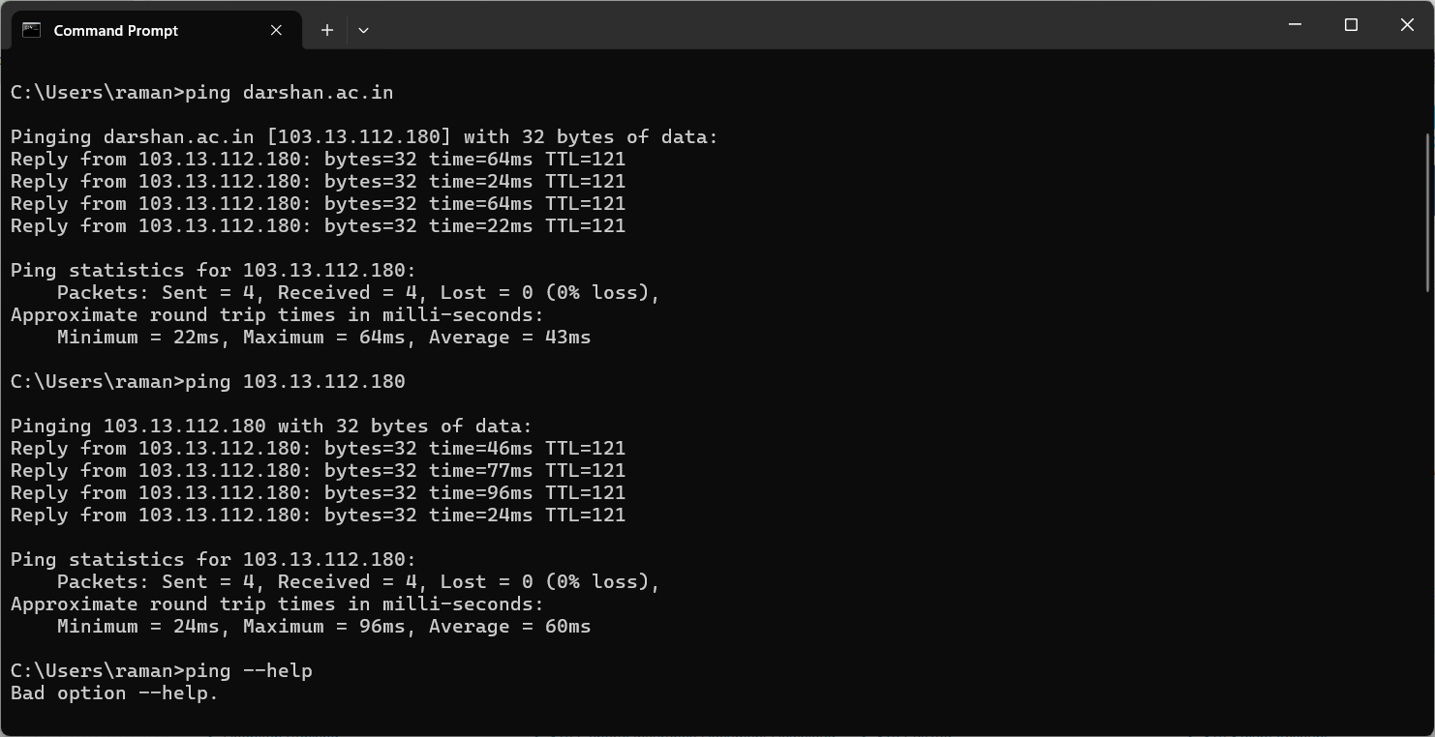

**ping -t 103.13.112.180**

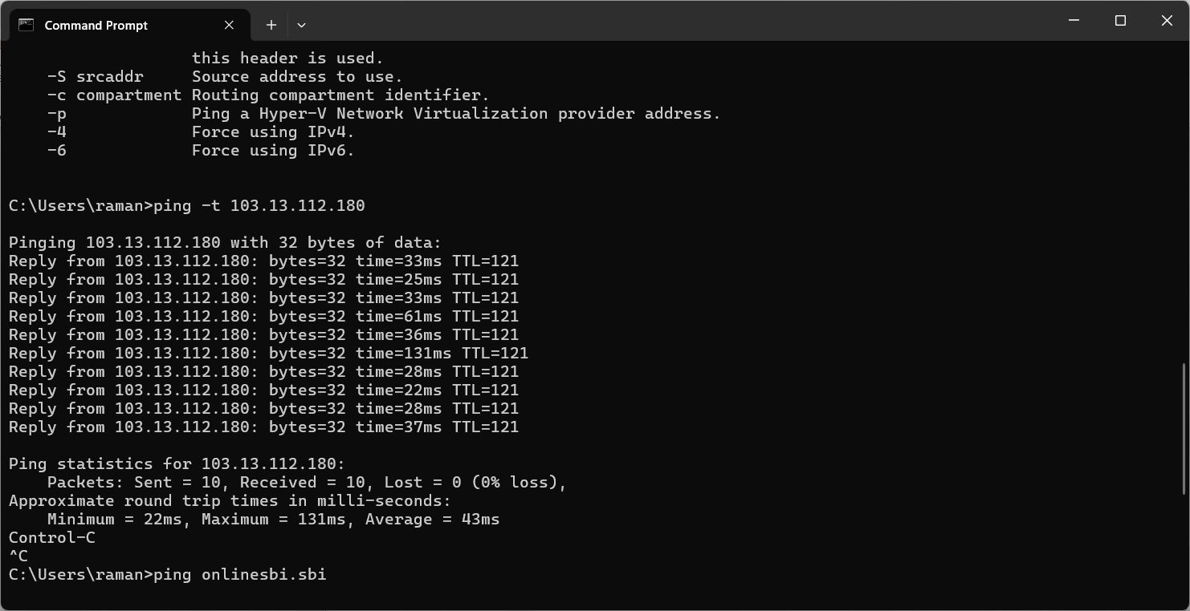

**ping -n 10 103.13.112.180**

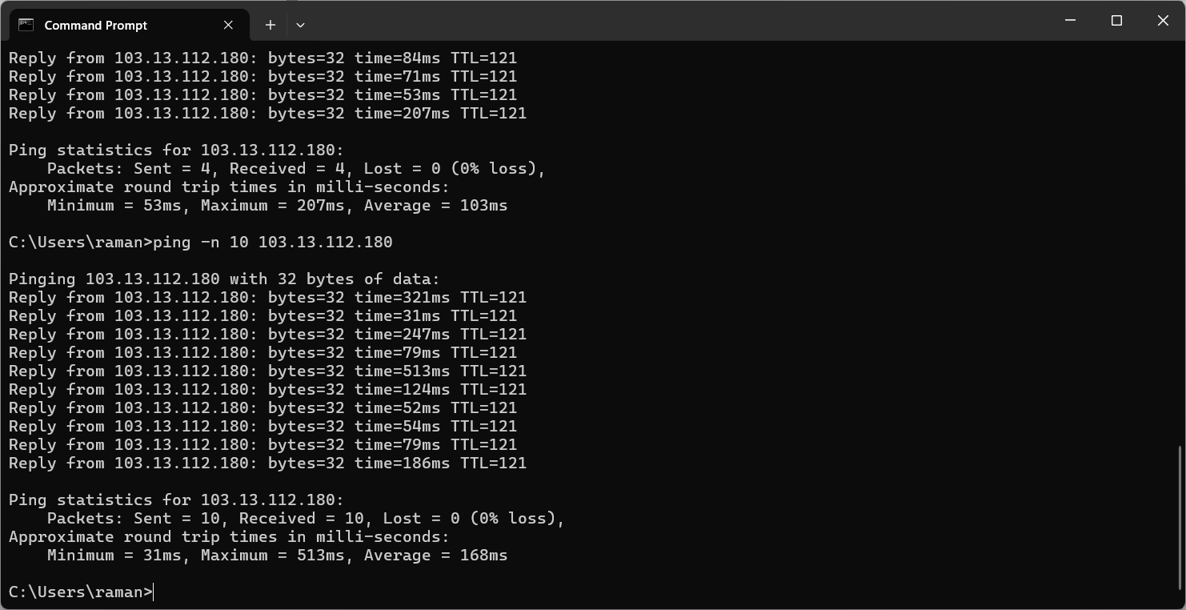

**ping -4 darshan.ac.in  
**

**ping -6 darshan.ac.in**

**ping -i 2 103.13.112.180**

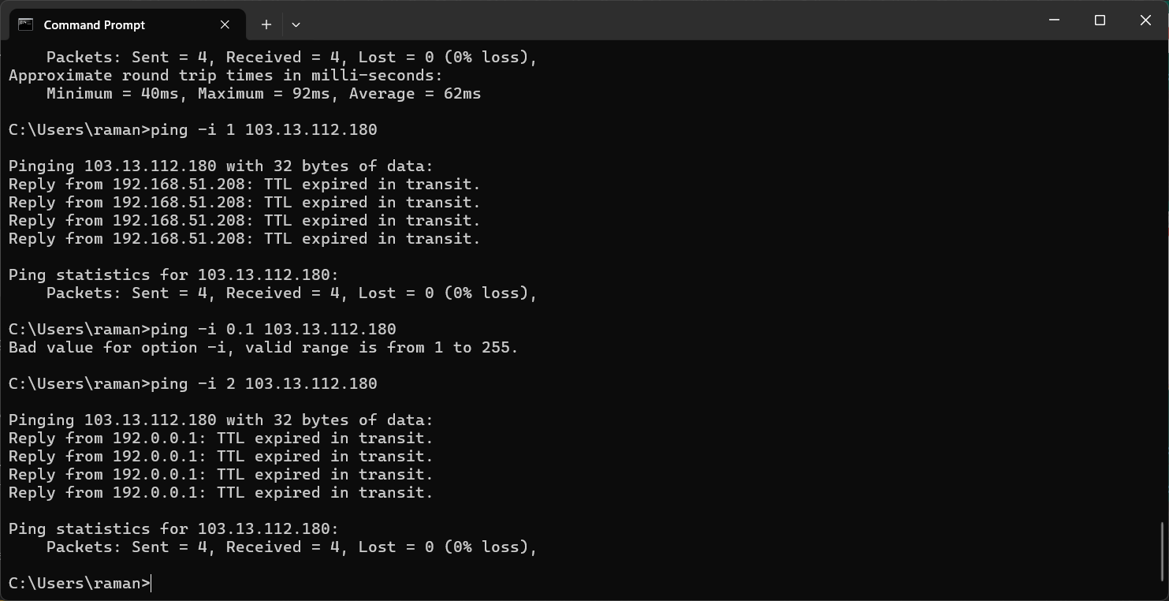

## getmac

### Description: getmac is used to display the Media Access Control (MAC) address and list of network adapters in the system.

**--------- Details About Command ------**

|  |  |  |
| --- | --- | --- |
| No. | Option | Description |
| 1 | getmac /FO [FORMAT] | Specifies the format in which the output is to be displayed. Valid formats: "TABLE", "LIST", "CSV". |
| 2 | getmac /S [SYSTEM_NAME] | Specifies the remote system to connect to. |
| 3 | getmac /V | Specifies that verbose output is displayed. |
| 4 | getmac /NH | Specifies that the "Column Header" should not be displayed in the output. Valid only for TABLE and CSV formats. |
| 5 | getmac /? | Displays this help message. |

### Implementation:

**getmac /FO list**

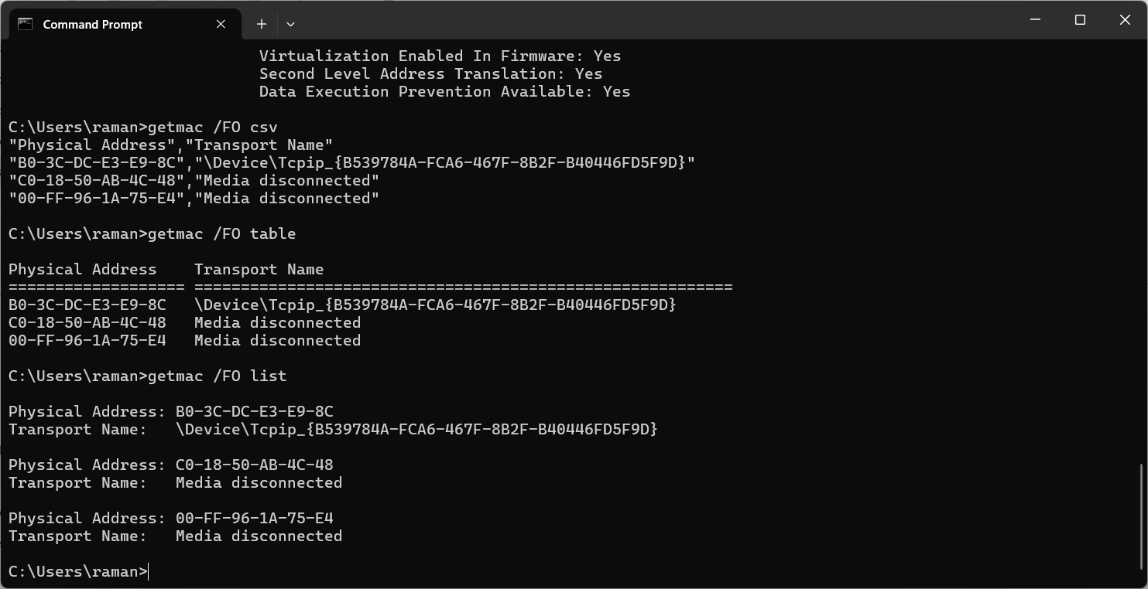

**getmac /S JAY_PATEL**

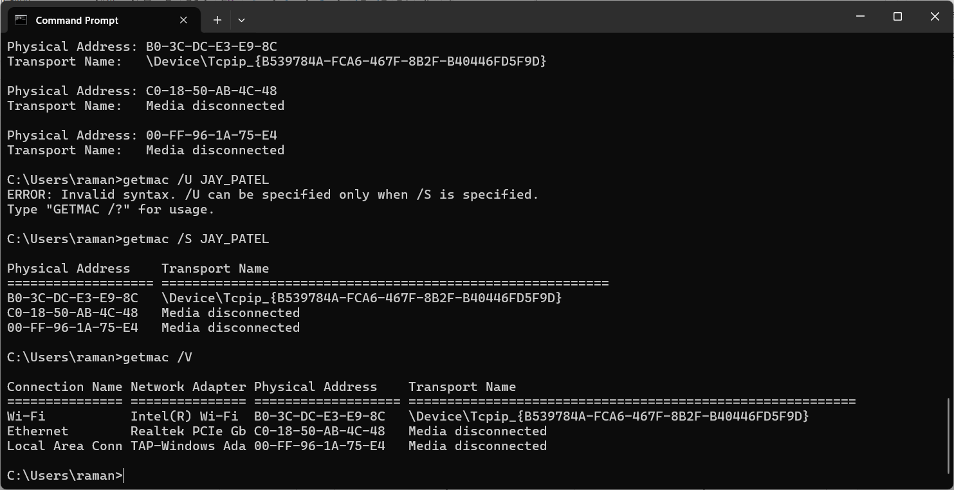

**getmac /V**



**getmac /NH**

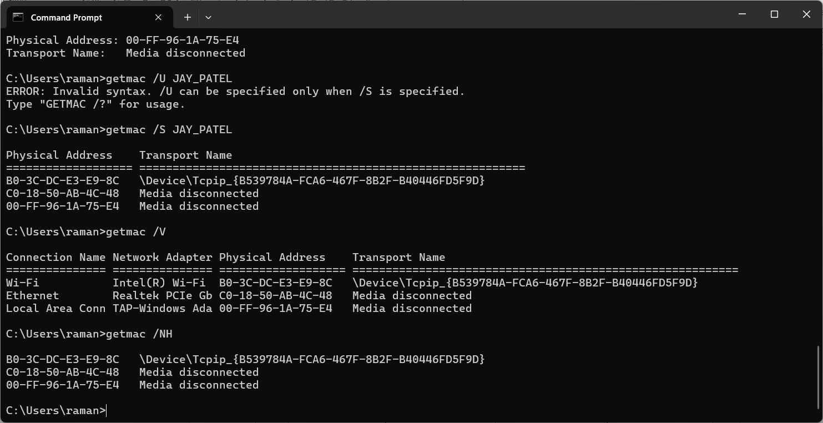

**getmac /?**

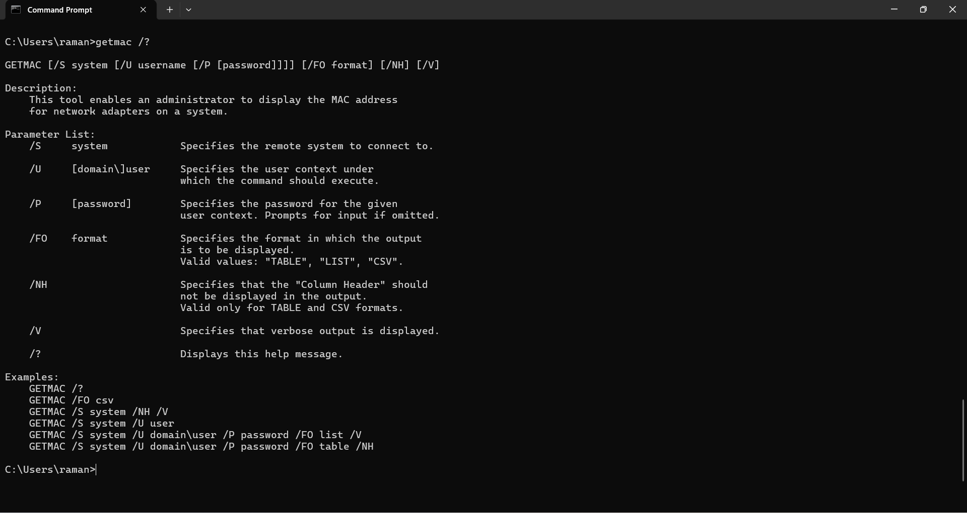

## systeminfo

### Description: Displays detailed configuration information about a computer and its operating system.

**--------- Details About Command ------**

|  |  |  |
| --- | --- | --- |
| No. | Option | Description |
| 1 | systeminfo /FO [FORMAT] | Specifies the format in which the output is to be displayed. Valid formats: "TABLE", "LIST", "CSV". |
| 2 | systeminfo /S [SYSTEM_NAME] | Specifies the remote system to connect to. |
| 3 | systeminfo /U | Specifies the user context under which the command should execute. |
| 4 | systeminfo /NH | Specifies that the "Column Header" should not be displayed in the output. Valid only for TABLE and CSV formats. |
| 5 | systeminfo /? | Displays this help message. |

### Implementation:

**systeminfo /FO csv**

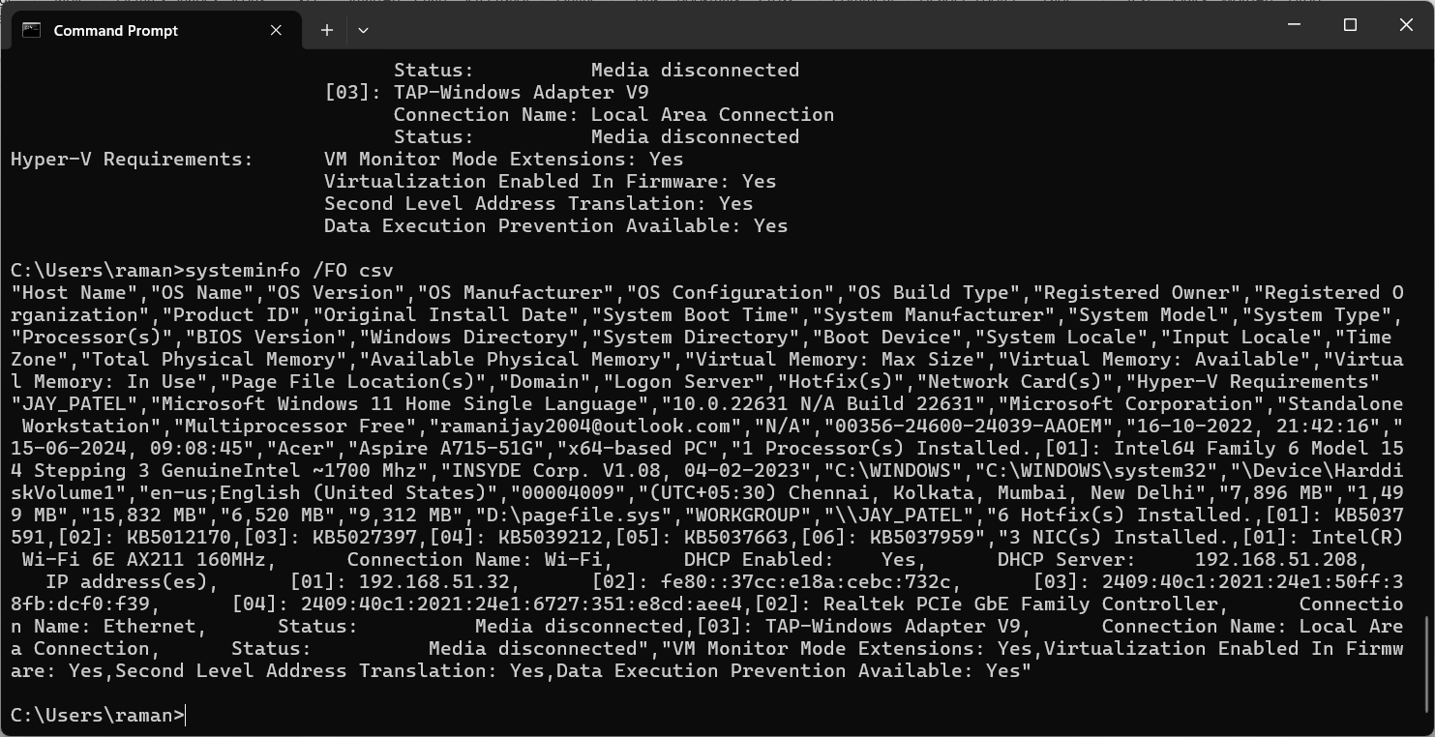

**systeminfo /S JAY_PATEL**

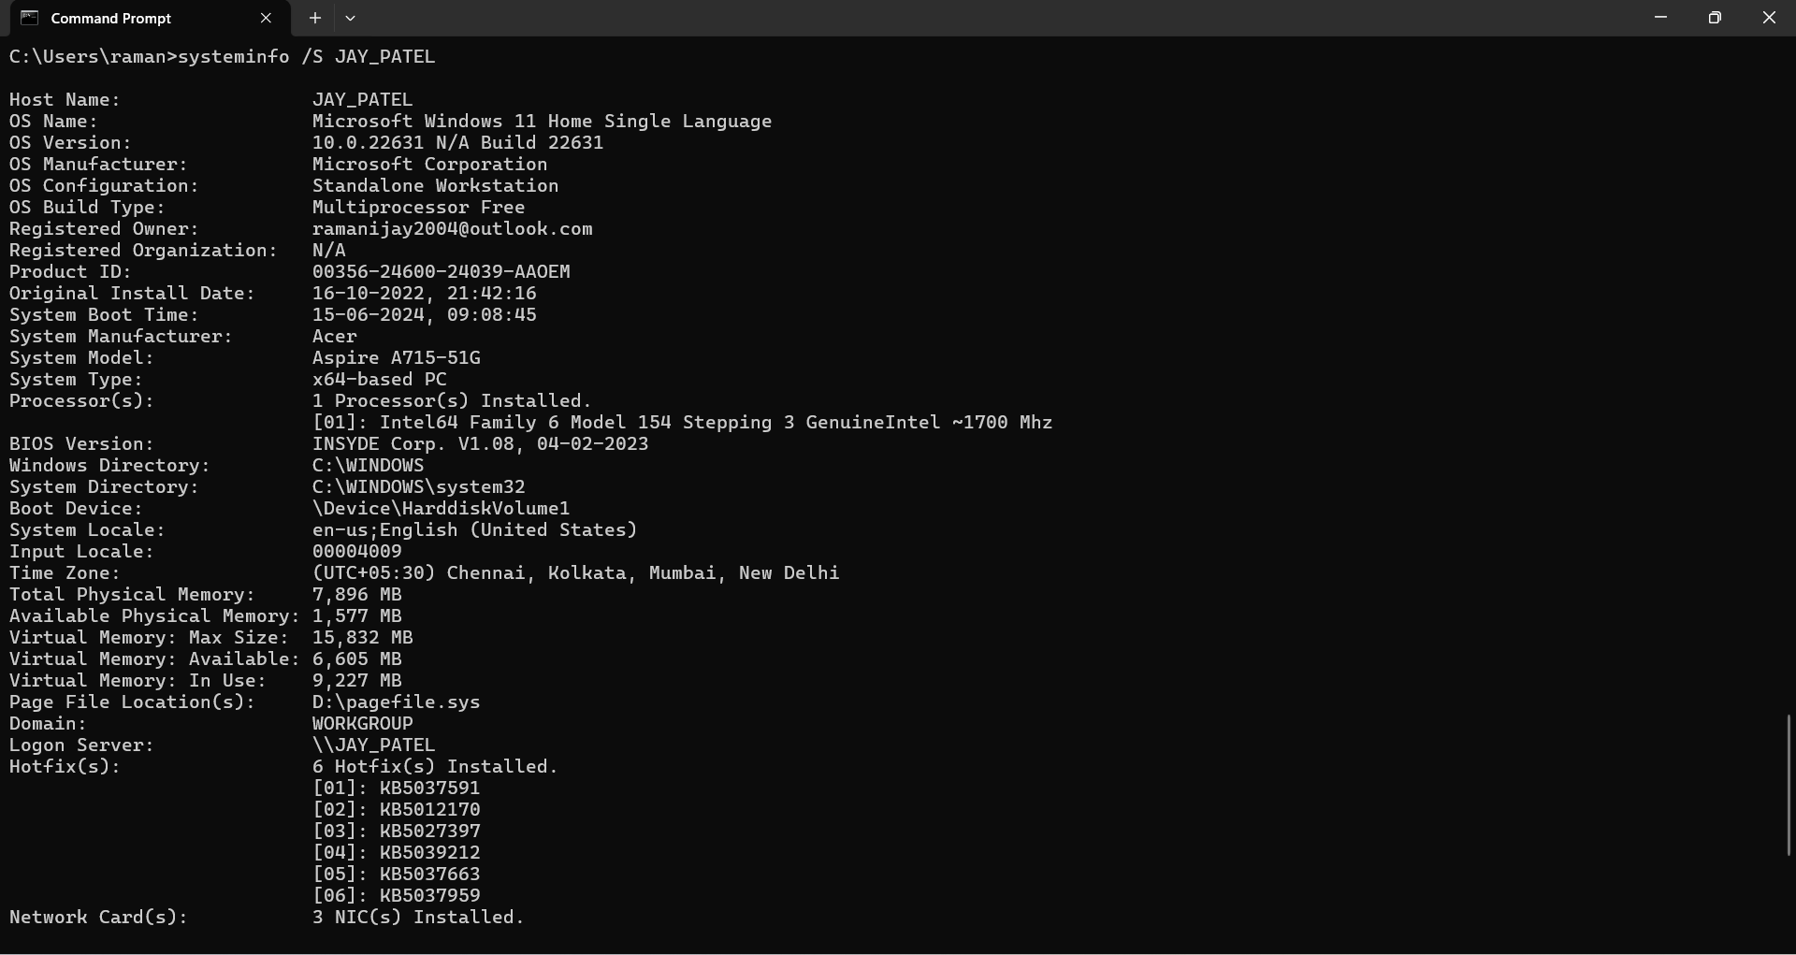

**systeminfo /S JAY_PATEL /U WORK_GROUP**

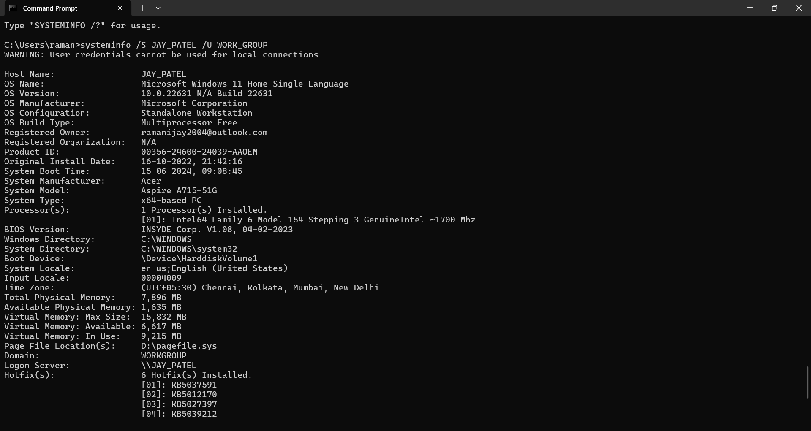

**systeminfo /FO table /NH**

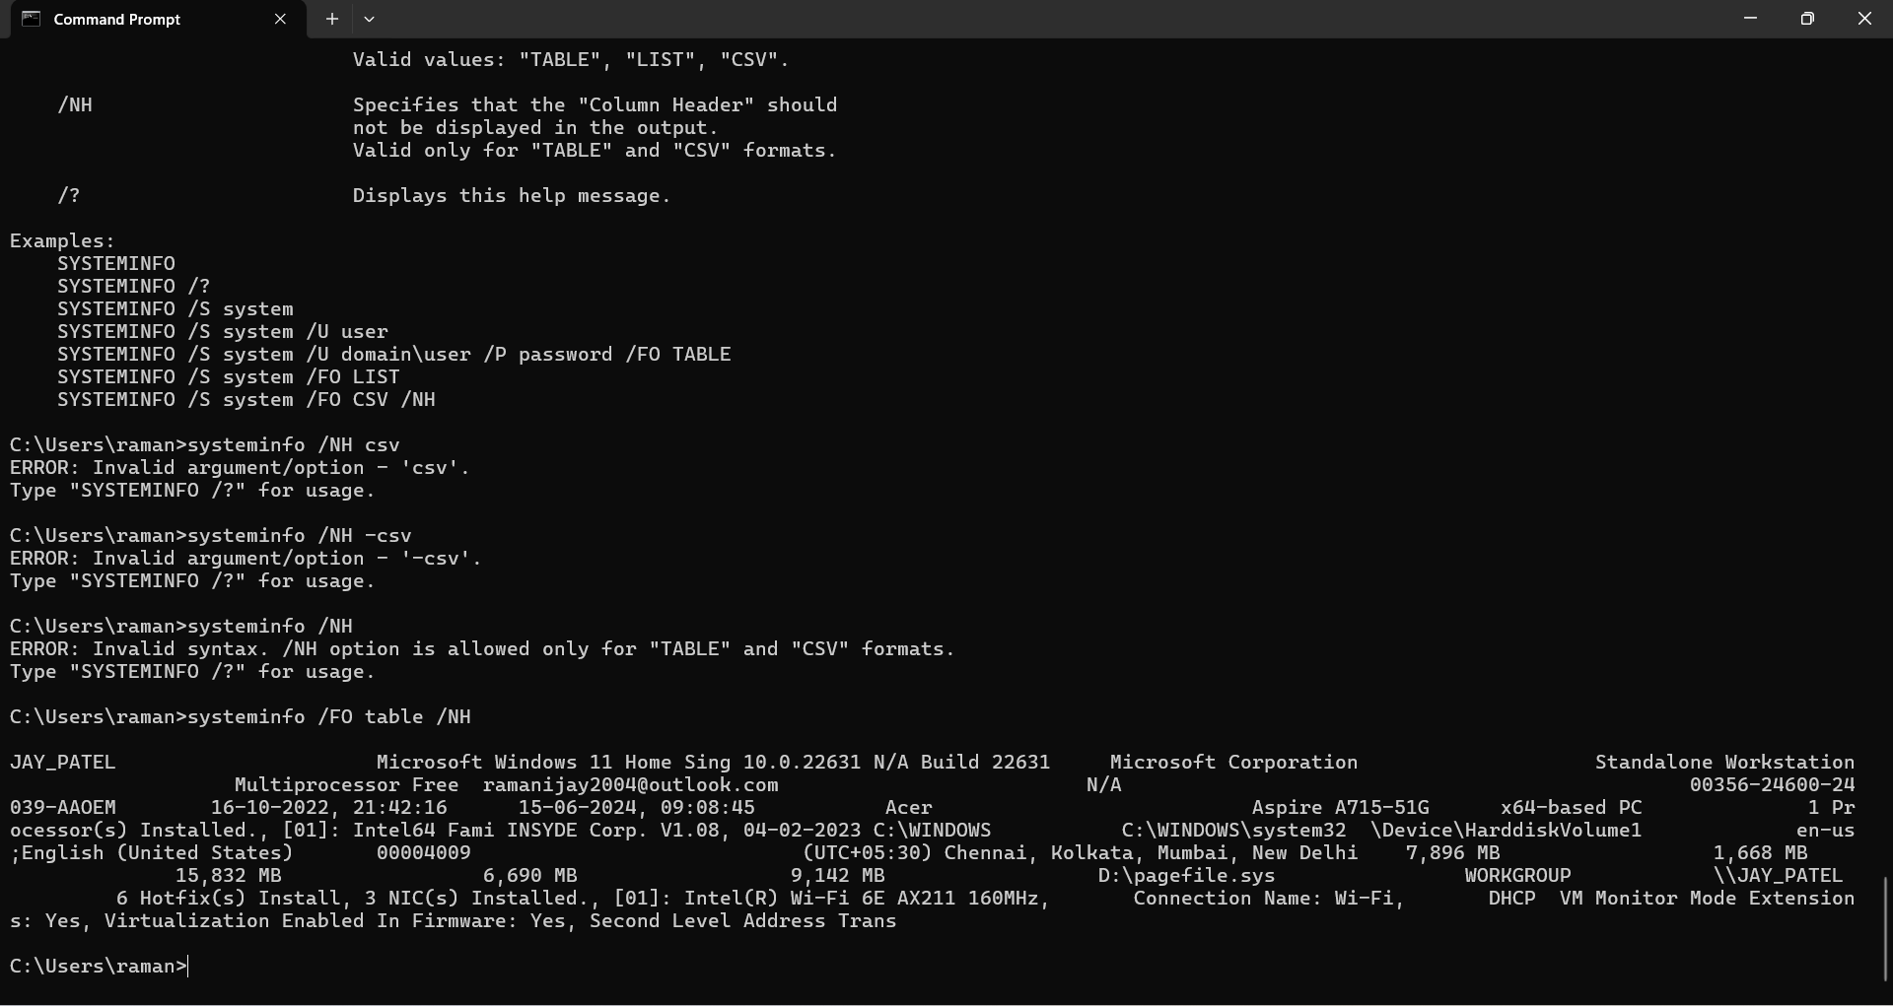

**systeminfo /?**

## traceroute / tracert

### Description: The Traceroute command (tracert) is a utility designed for displaying the time it takes for a packet of information to travel between a local computer and a destination IP address or domain.

**--------- Details About Command ------**

|  |  |  |
| --- | --- | --- |
| No. | Option | Description |
| 1 | tracert -d [DOMAIN_NAME/IP] | Do not resolve addresses to hostnames. |
| 2 | tracert -h [NUMBER] [DOMAIN_NAME/IP] | Maximum number of hops to search for target. |
| 3 | tracert -j [DOMAIN_NAME/IP] | Loose source route along host-list (IPv4-only). |
| 4 | tracert -4 [DOMAIN_NAME/IP] | Force using IPv4. |
| 5 | tracert -6 [DOMAIN_NAME/IP] | Force using IPv6. |

### Implementation:

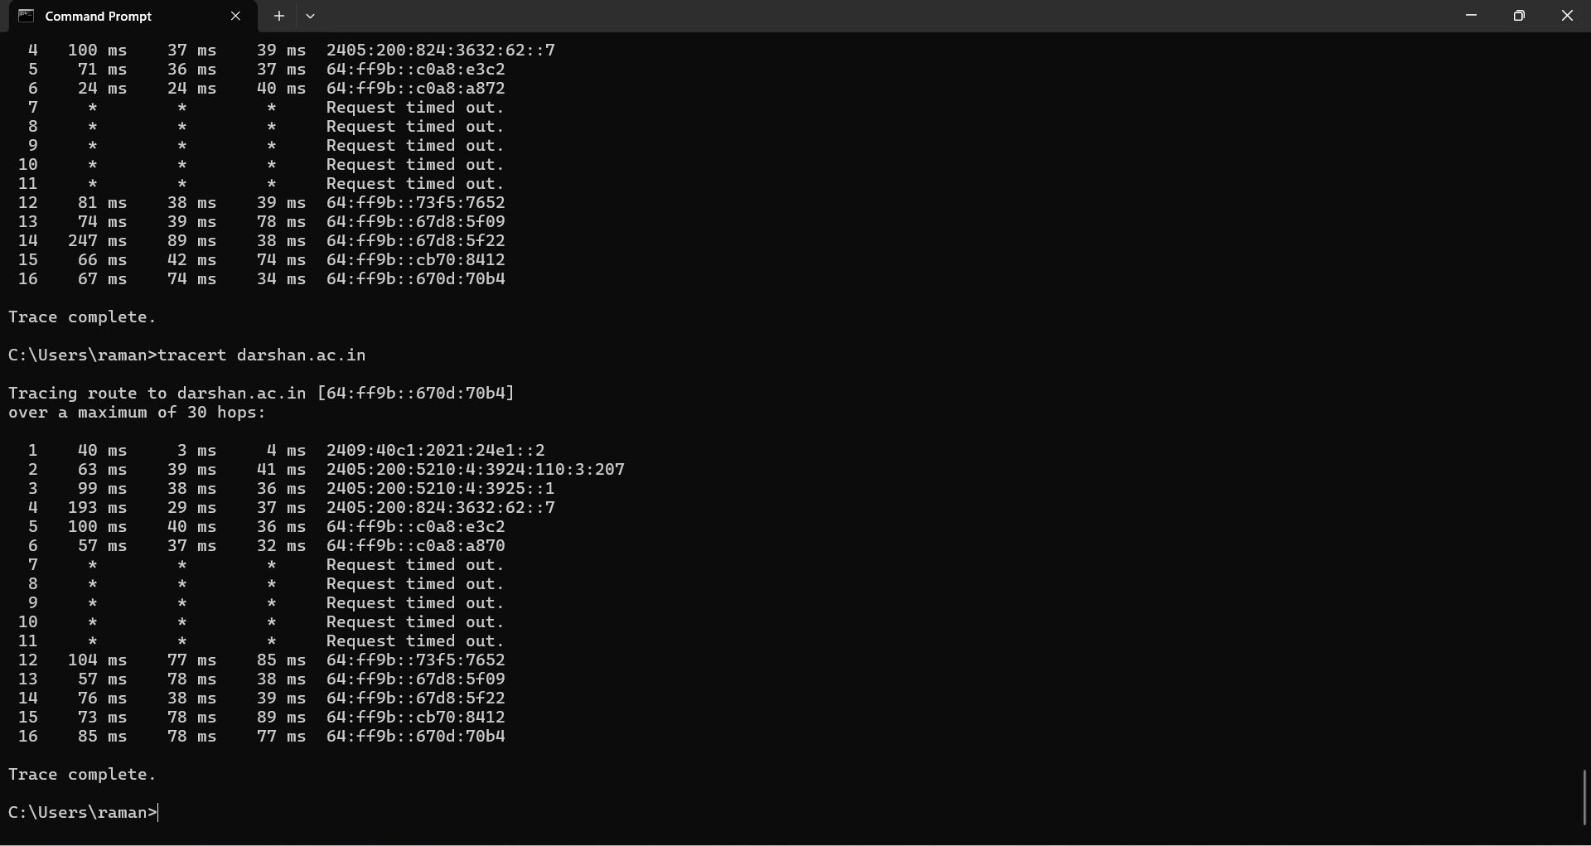

**tracert -d darshan.ac.in**

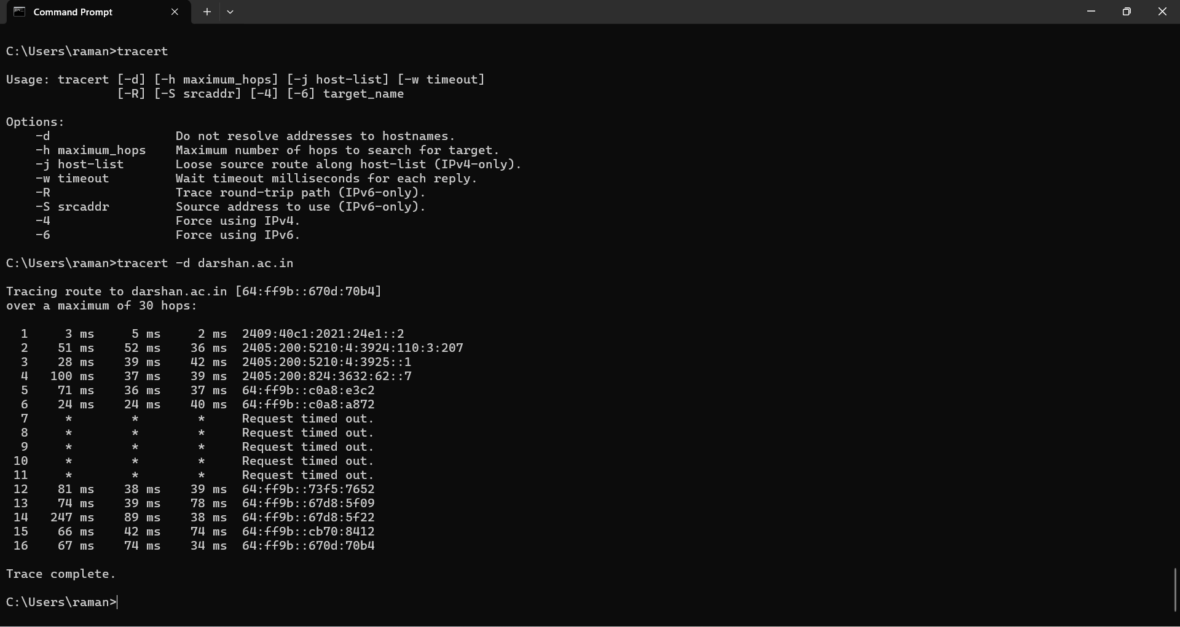

**tracert -h 5 darshan.ac.in**

**tracert -j darshan.ac.in**

**tracert -4 darshan.ac.in**

**tracert -6 darshan.ac.in**

## netstat

### Description: The network statistics (netstat) command is a networking tool used for troubleshooting and configuration, that can also serve as a monitoring tool for connections over the network.

**--------- Details About Command ------**

|  |  |  |
| --- | --- | --- |
| No. | Option | Description |
| 1 | netstat -e | Displays Ethernet statistics. This may be combined with the -s option. |
| 2 | netstat -f | Displays Fully Qualified Domain Names (FQDN) for foreign addresses. |
| 3 | netstat -i | Displays the time spent by a TCP connection in its current state. |
| 4 | netstat -n | Displays addresses and port numbers in numerical form. |
| 5 | netstat -o | Displays the owning process ID associated with each connection. |

### Implementation:

**netstat -e**

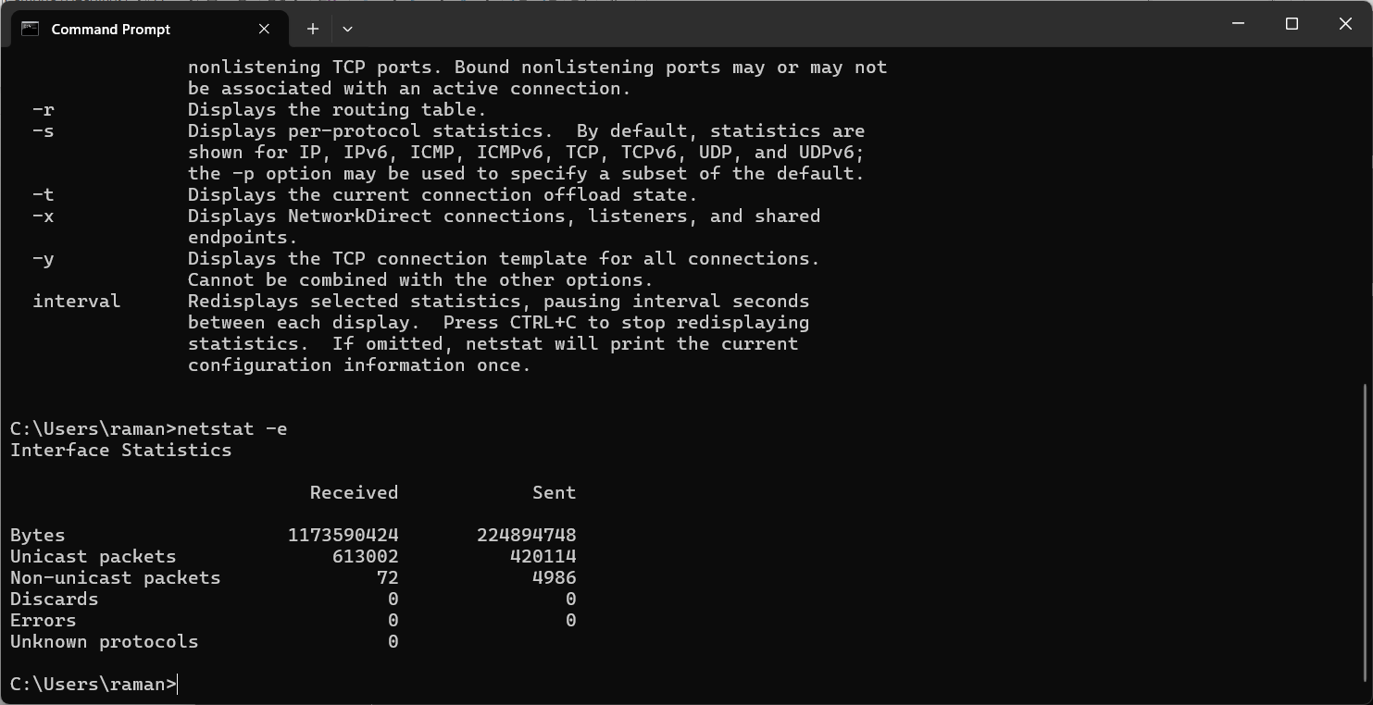

**netstat -f**

**netstat -i**

**netstat -n**

**netstat -o**

## nslookup

### Description: The nslookup command queries internet domain name servers in two modes.

**--------- Details About Command ------**

|  |  |  |
| --- | --- | --- |
| No. | Option | Description |
| 1 | set debug | You can get additional information about a domain name by using this DNS command. |
| 2 | set q=soa | Another useful CMD DNS command is the SOA record command. Getting the SOA record of a domain is fairly simple and similar to the last DNS command. The only difference is that you set the query type to “*soa”* instead of “*ns”*. |

### Implementation:

**> set debug**

**> darshan.ac.in**

**> set q=soa**

**> darshan.ac.in**

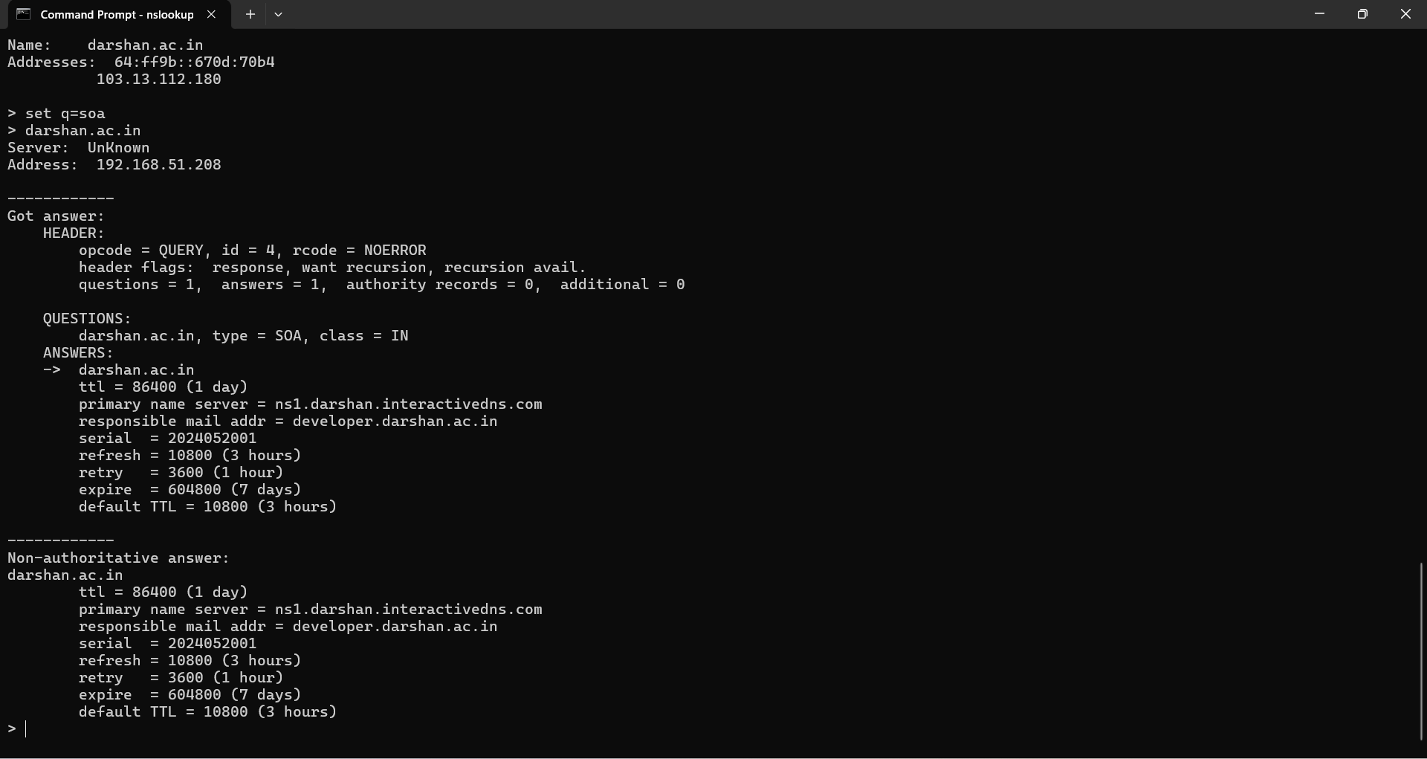

## hostname

### Description: Hostname command in Linux is used to obtain the DNS (Domain Name System) name and set the system's hostname or NIS (Network Information System) domain name.

### Implementation:

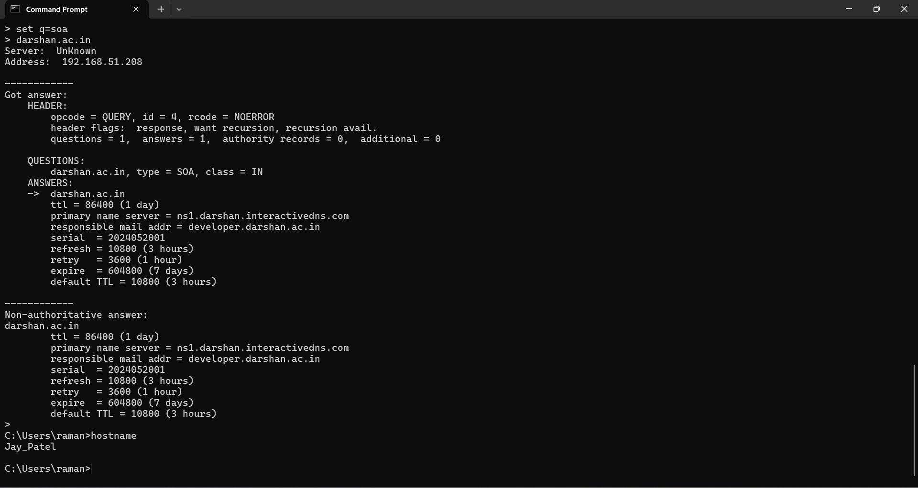

## pathping

### Description: The PathPing command is a command-line network utility included in Windows NT operating systems since Windows 2000 that combines the functionality of ping with that of tracert.

**--------- Details About Command ------**

|  |  |  |
| --- | --- | --- |
| No. | Option | Description |
| 1 | pathping -g darshan.ac.in | Loose source route along host-list. |
| 2 | pathping -h 2 darshan.ac.in | Maximum number of hops to search for target. |
| 3 | pathping -p 2 darshan.ac.in | Wait period milliseconds between pings. |
| 4 | pathping -4 darshan.ac.in | Force using IPv4. |
| 5 | pathping -6 darshan.ac.in | Force using IPv6. |

### Implementation:

**pathping -g darshan.ac.in**

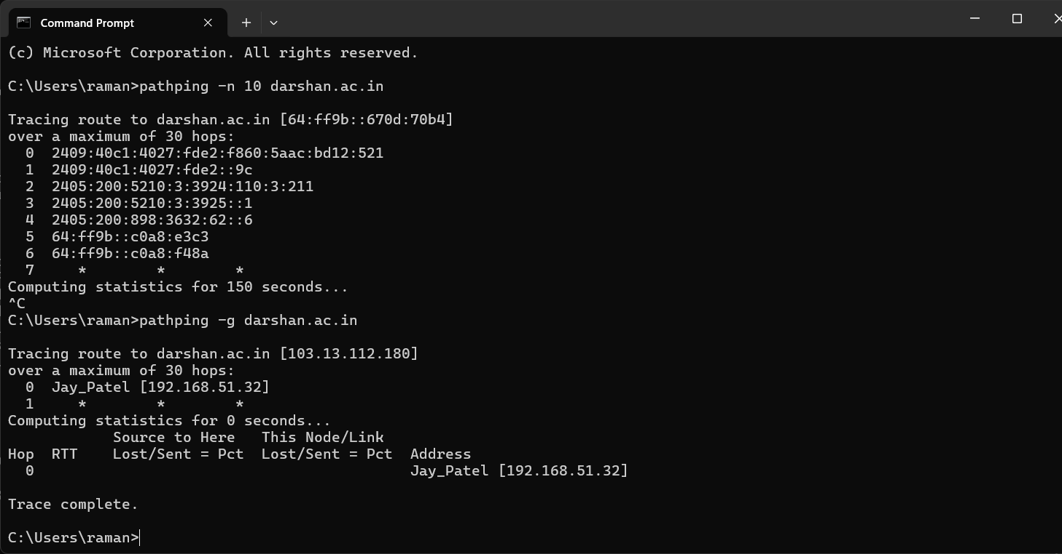

**pathping -h 2 darshan.ac.in**

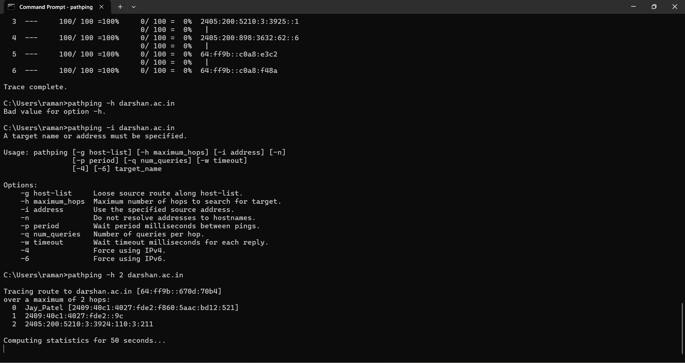

**pathping -p 2 darshan.ac.in**

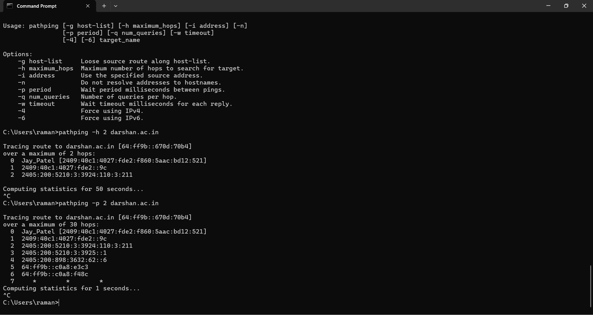

**pathping -4 darshan.ac.in**

**pathping -6 darshan.ac.in**

## arp

### Description: Arp command manipulates the System's ARP cache.

**--------- Details About Command ------**

|  |  |  |
| --- | --- | --- |
| No. | Option | Description |
| 1 | arp /a | Displays current ARP entries by interrogating the current protocol data. |

### Implementation:

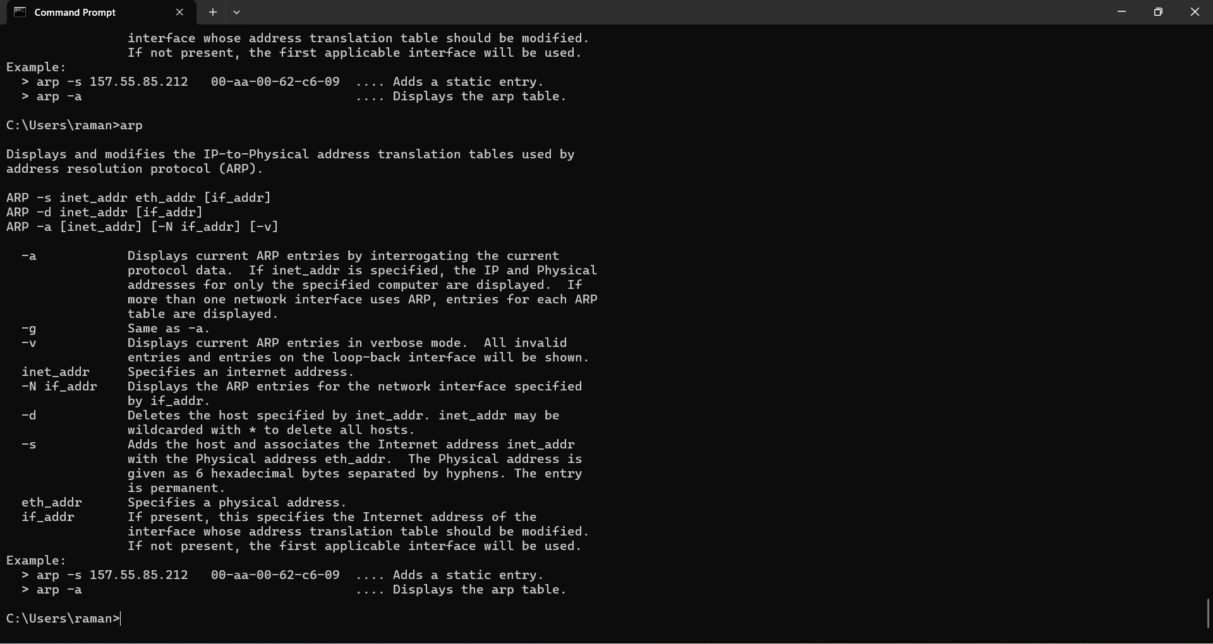

**arp /a**

